Website Changes

Homepage
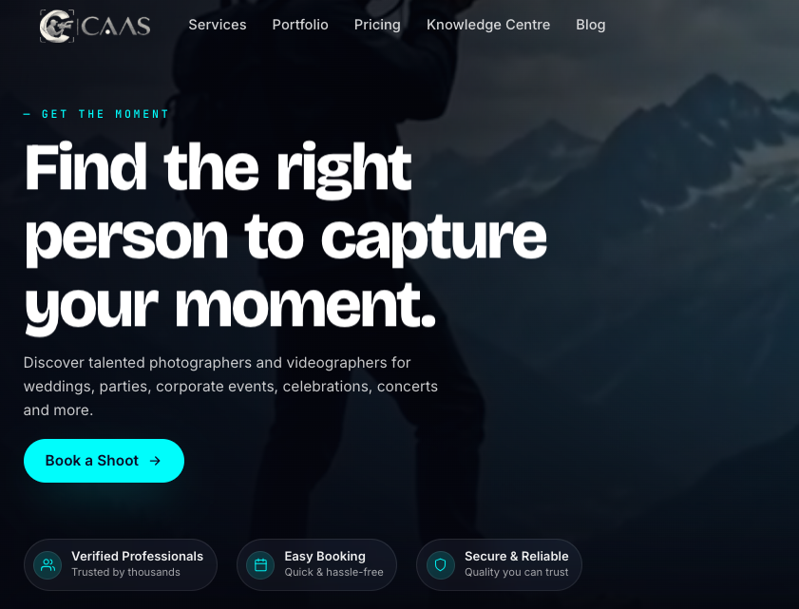 (current)

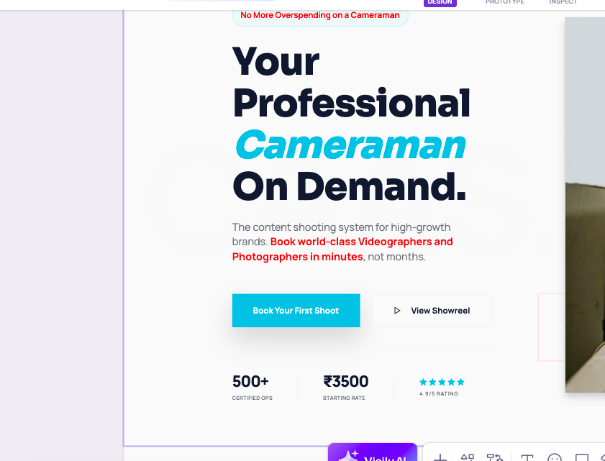 (to be added)
Change the content



Change cyan color used in SHOOT to - #46bbdf
In all the heading only

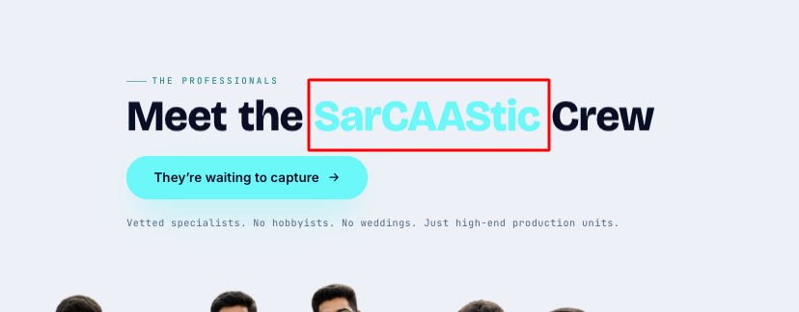
Similarly here
Change cyan color used in SHOOT to - #46bbdf
In all the heading only

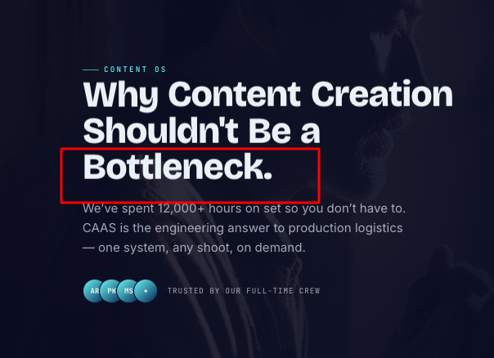
Make Bottleneck in Red Color

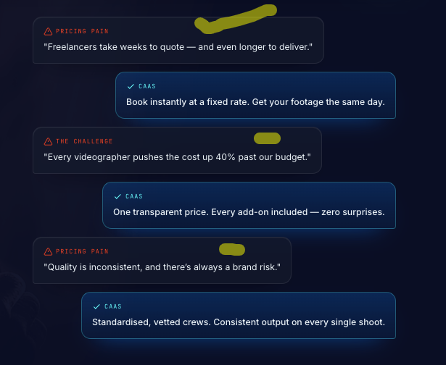

Change bg color to beige or off white color and font color red and black on same

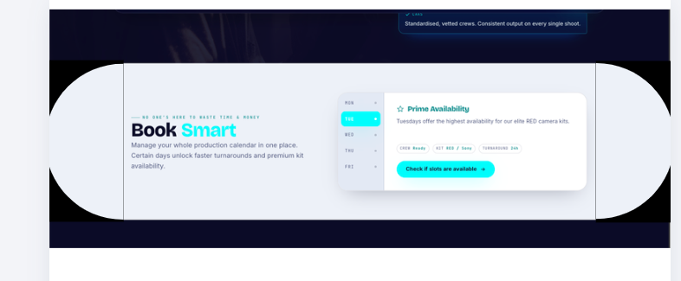
Make this section more attractive as this is not creating impact right now
This is one of our main CTA that directs customer so utilize this space

RealLifeStoriesonSet

01 — THE “ONE LAST SHOT”
“One last shot.”
Said at 5:40 PM.
We were still shooting at 8:15.
Somewhere between the 11th “last shot” and the 14th, the client stopped being the client and started roasting us for still having energy.
Punchline:
That’s when you know the shoot went well.

02 — THE CAMERA SHY CLIENT
“I’m really awkward on camera.”
First take: awkward.
Second take: nervous.
Third take: everyone started laughing.
By take seven, the client was improvising better than the script.
Punchline:
The camera stopped feeling like a camera. That’s the real win.

03 — WHEN EVERYTHING GOES WRONG
Battery: 3%.
Memory card: full.
Weather: changed its mind.
Client: “Can we still get the shot?”
Somehow, everyone jumped in.
Someone found a charger. Someone held the reflector. Someone ordered chai.
Punchline:
The shot worked. The chaos became the story.

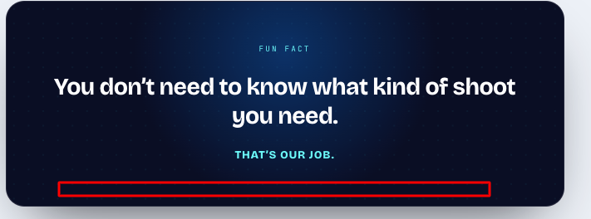

Add: No One is here to Waste Time & Money,

Make this fun fact looks more supported with cameraman or shoot setup or some graphics that highlights the camera setup along side fun fact content
That would make user more oriented towards worth stopping and seeing to it

Something like this
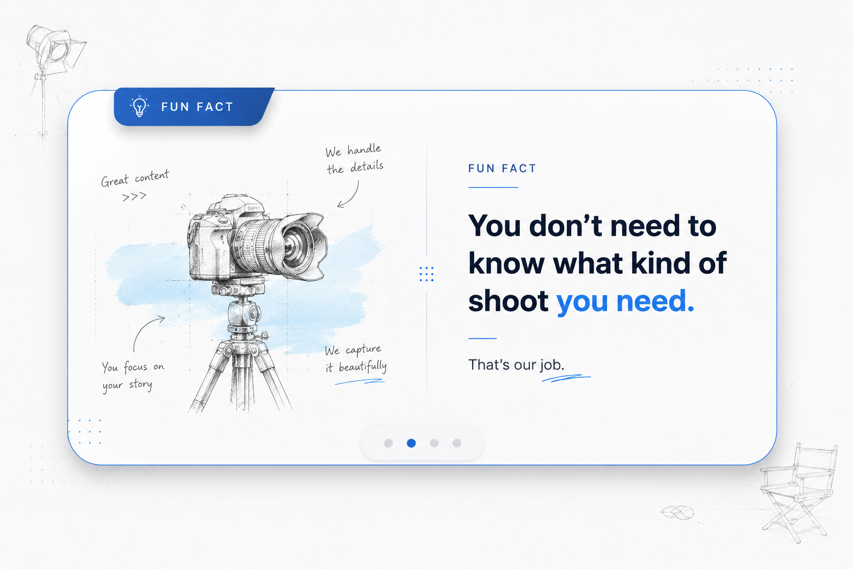



Text - Industries We Serve

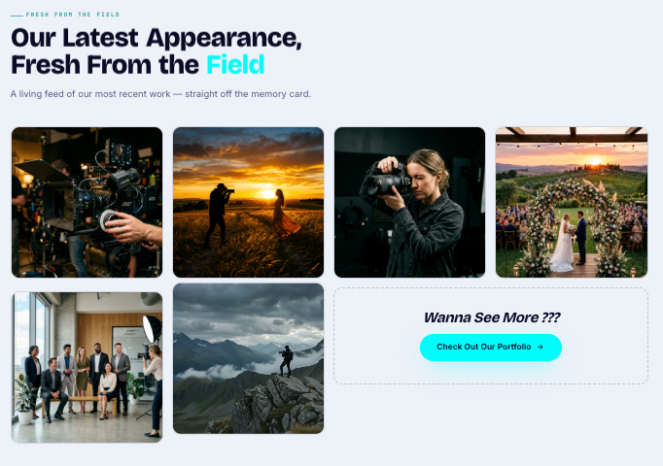

1- CHANGE COLOR CODE OF FIELD
2- Make images dimension smaller - and CTA text sould be red and box should be big

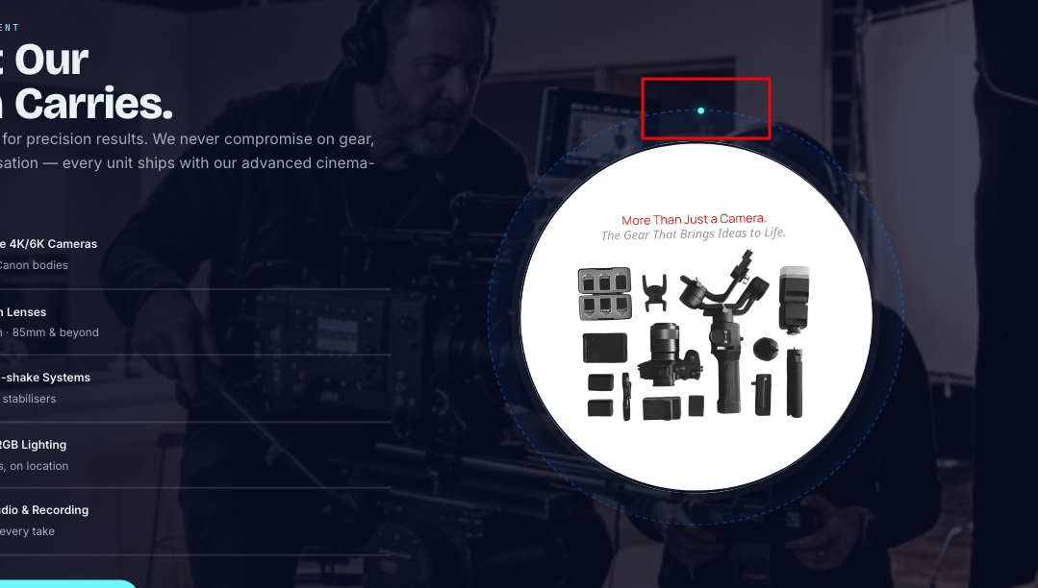

Can we add lens frame around white image and when anyone comes to this section it drops a flash light and shows animation as in someone has clicked the photo?

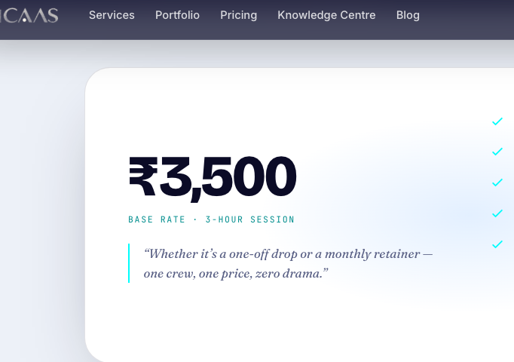

3500 for 5 hrs 30 mins - including break
500 for every extra hour

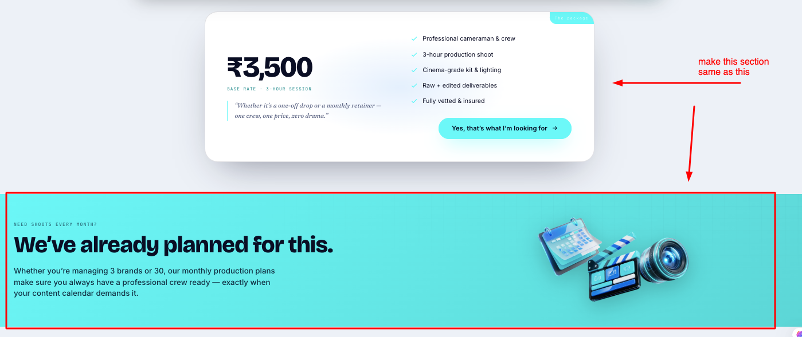

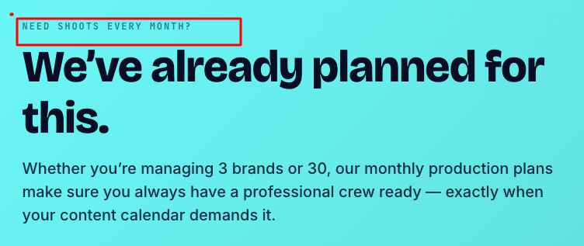

Make highlighted section bigger in size and reduce the size of text below that
Also change font color to red for highlighted text

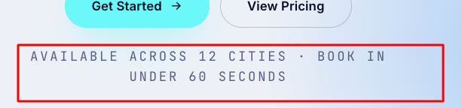

Available across NCR region for now,
Get verified bookings under 60 seconds

SERVICE PAGE
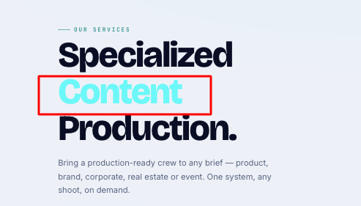

Change color code to #46bbdf

Change supporting text - Hiring a professional cameraman shouldn't depend on luck, availability or endless phone calls.

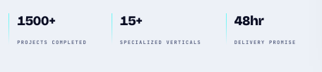

150+ Projects completed
15+ Vertices with Camera
36-48 hrs delivery

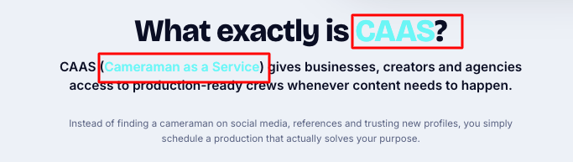

Change color code here

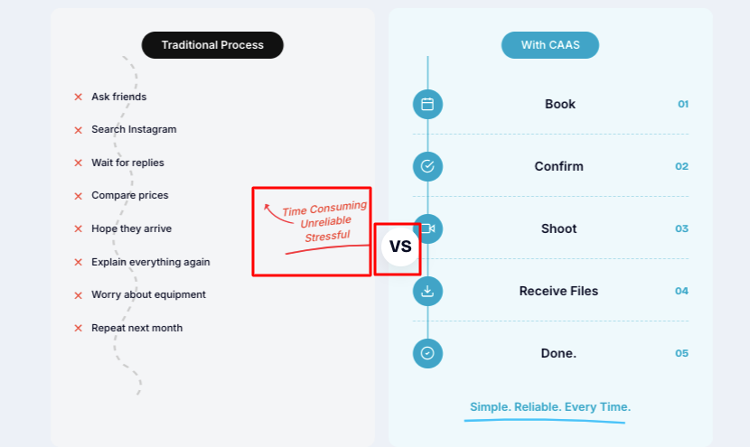

Fix alignment

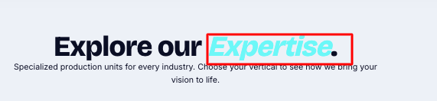
Change color code

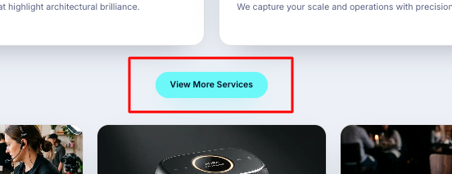

Make this Look like heading instead of CTA Box
Should look bit more big in font size

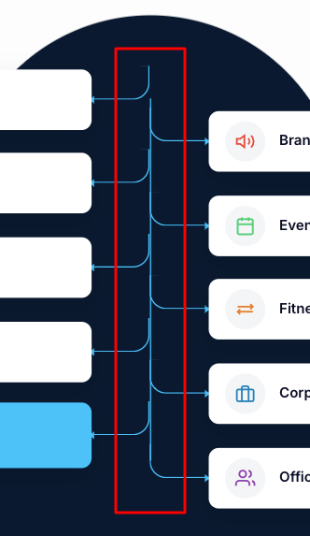 fix the line alignment

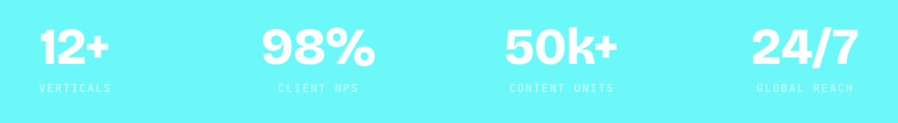
Make font black color or probable shade of gray that is visible

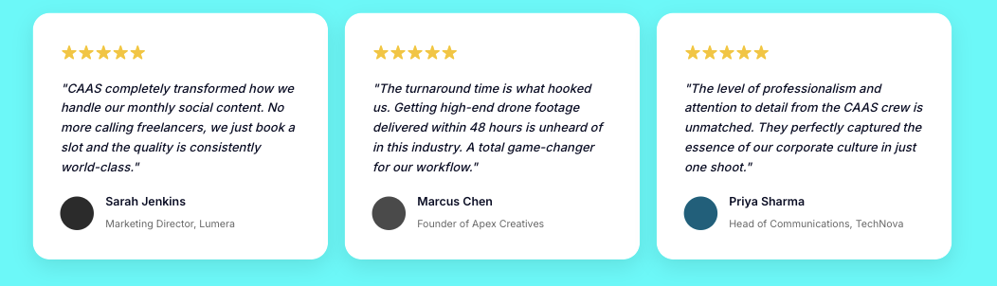

Change reviews

Neha Khurana
Restauranter | Gurugram
“CAAS ne hamara pura content game change kar diya. Pehle har mahine freelancers dhoondhne ka tension rehta tha, ab bas slot book karo aur tension khatam. Quality itni consistent hai ki ab hum bina soche inpe bharosa karte hain.”
★★★★★

Review 2 — Rohan Mehta
Founder, The Wadhwa Realtors
“48 hours mein premium drone footage milna pehle impossible lagta tha. CAAS ne jo turnaround diya hai na, usne humare project ki puri planning easy kar di. Professional team, proper process aur output bilkul next level.”
★★★★★

Review 3 — Anjali Verma
Brand Manager, Surbhi Designs | Delhi
“Jo cheez CAAS ki team set pe leke aati hai na, woh sirf camera ya gear nahi hota — unka professionalism aur detailing next level hai. Ek shoot mein hi unhone hamari brand vibe itni achhe se samajh li ki har frame on-point tha.”

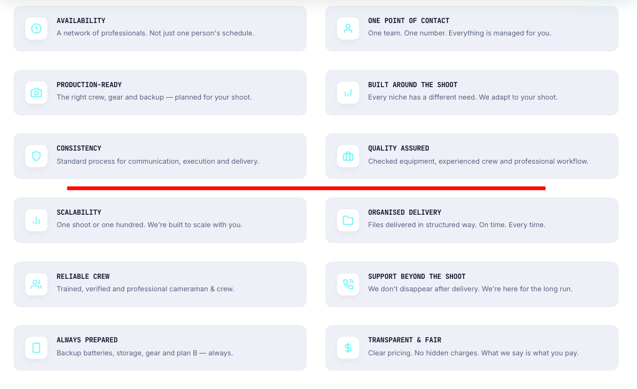
Add: We’re here to deliver your presence, not negotiate our worth — good karma, great work, zero shortcuts.

PORTFOLIO
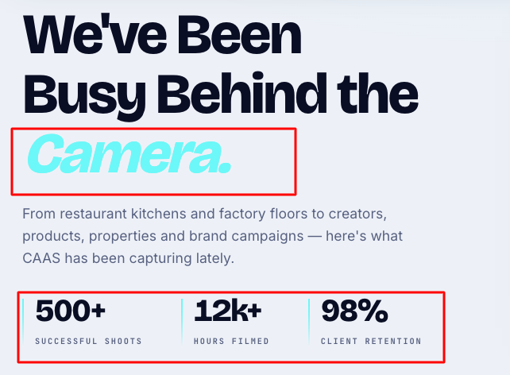

Change font color of camera to #46bbdf

Change data to
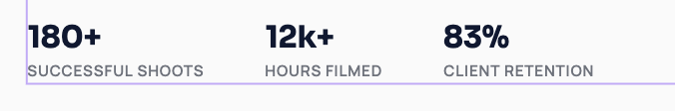

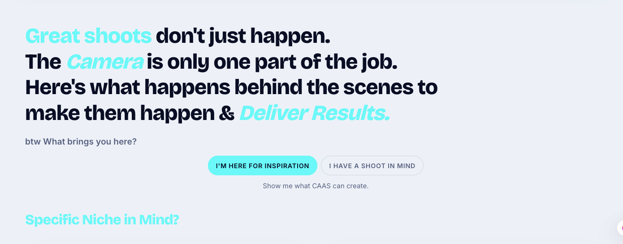
This section looks cluttered
Idea is to show a statement just after video,
I am here for inspiration - would show them different clients we work with but when someone clicks - I have a Shoot in mind, a popup should come up with questions
NAME, BUSINESS, SHOOT DETAILS, LOCATION, INDUSTRY, DATE, and so on

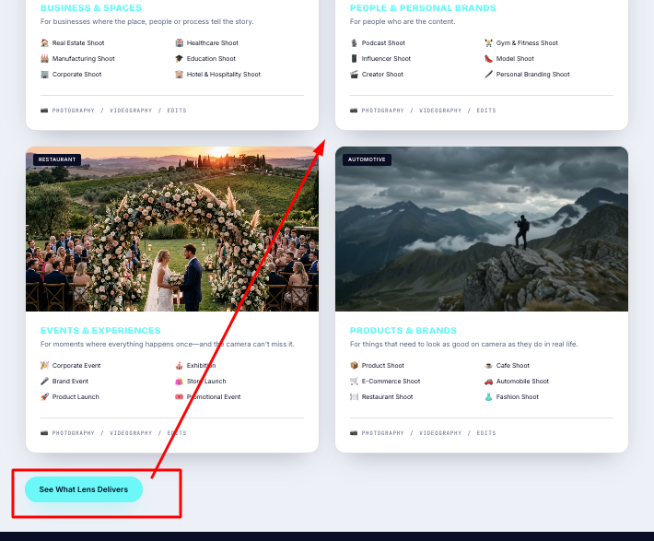
Move this CTA Box in centre of 4 widgets showing niche and it should have
PDF downloaded everytime someone clicks on it

Reframe this
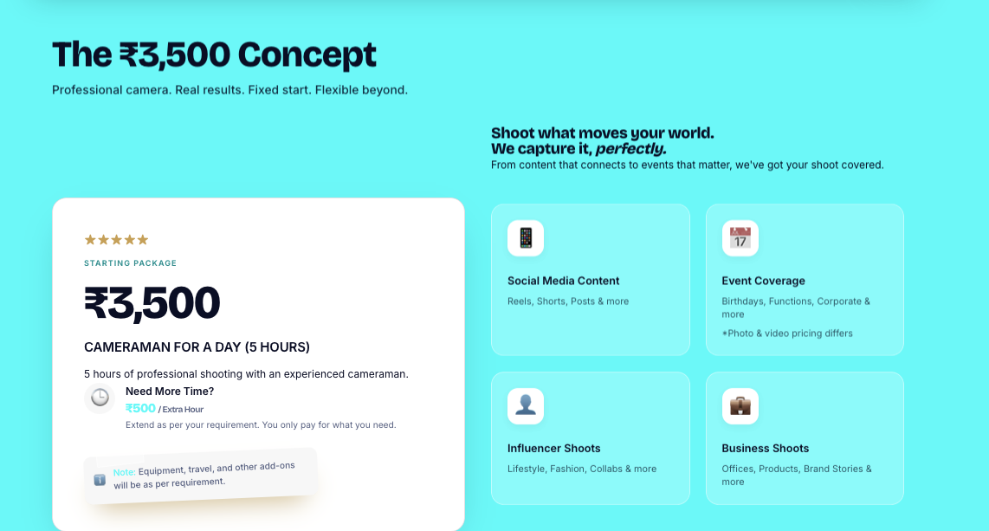

To this,
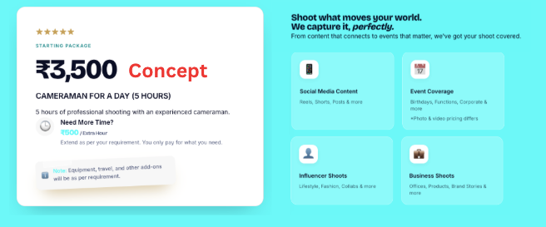

Make sure to add CTA Button and adjust them properly

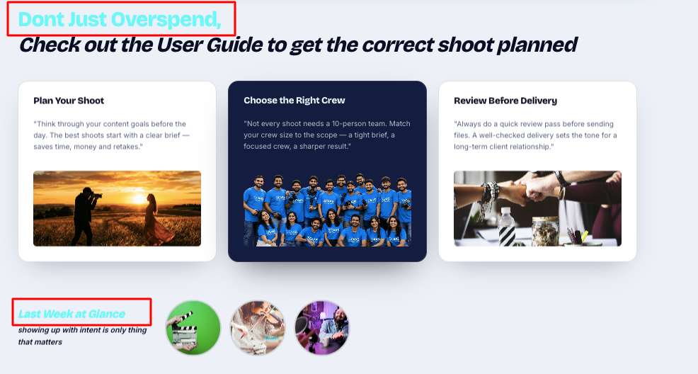
Change font color


- Change this pricing to Contact us
- And add dropdown in knowledge centre section in which we will show,
Blogs, Guides, Case Studies, News & Trends

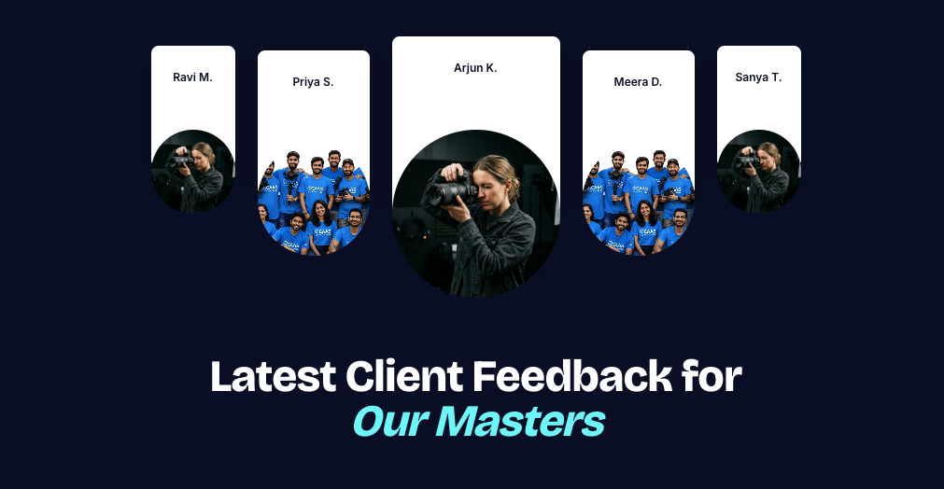

Ravi M. – Bro shot my brand video like a Netflix trailer 🎬
Priya S. – Took 200 photos of our team and somehow everyone looked good. Magic.
Arjun K. (center/main) – Been shooting for us 3 months now, still shows up before we're even ready. That's dedication.
Meera D. – Rude how talented this guy is honestly 😤 10/10
Sanya T. – Told him 'just casual pics' and he delivered a whole photoshoot. Never going back to anyone else.

PRICING PAGE

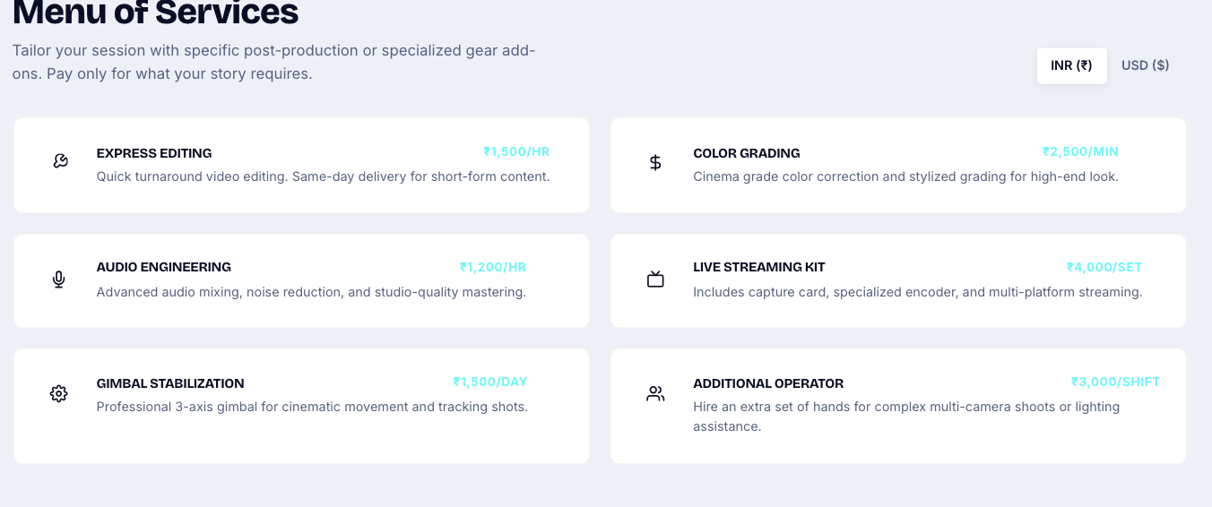
Remove pricing from each option, and give a feature in inquiry form a drop down to select any of these

Menu of Services
Express Editing
Quick-turnaround video editing for reels, social content, and short-form campaigns.
Audio Engineering
Clean, balanced, professional audio with mixing, noise reduction, and mastering.
Lighting Setup
Purpose-built lighting setups to make every subject, space, and shot look its best.
Advanced Lens & Modern Kit
Professional lenses and modern production gear to achieve the right look for your shoot.
Color Grading
Refined color correction and creative grading to give your footage its final visual character.
Discuss What's in Your Mind
Have an idea but not sure what you need? Tell us what you're planning, and we'll figure out the right setup together.

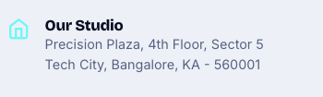

Address -
A5 - Krishna Nagar, East Delhi, 110051
Contact number
+91 7531074311

Images to be changed
Homepage
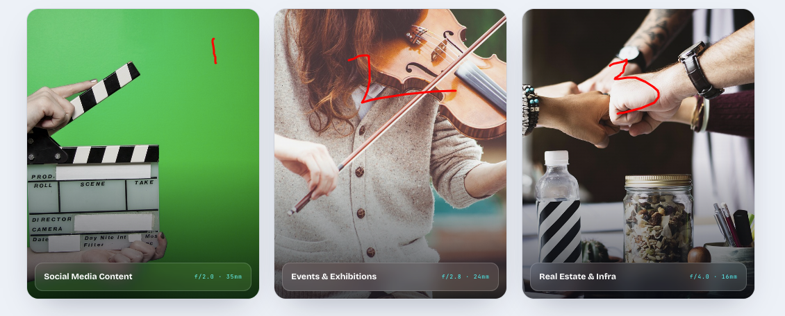
1- https://drive.google.com/file/d/1Cmf-CyryMgQPfqLuXsINCCngDN8wxLoX/view?usp=drive_link
2- https://drive.google.com/file/d/1YseD6aQD5Unzu2CsVhoqf7oG3-RymZU7/view?usp=drive_link
3- https://drive.google.com/file/d/1uK1UYhoIjZJcfqIrhRykoCbgBqQIlY3W/view?usp=drive_link

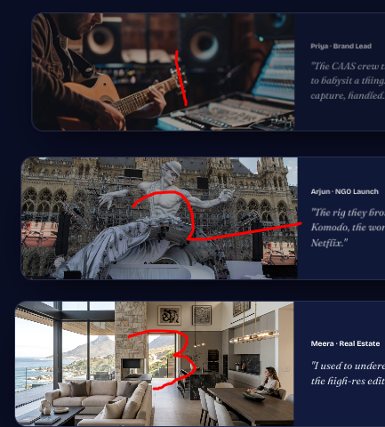
1- https://drive.google.com/file/d/108yn1kNebKoeH7dbrQuLCmHluPpxwfDa/view?usp=drive_link
2- https://drive.google.com/file/d/1XuMmxxMMLF1UbsuBOY_d6X-PHMwtlqBU/view?usp=drive_link
3- https://drive.google.com/file/d/1E4VuVajV3wTf6EwKacN3pCkZzpjFXy1F/view?usp=drive_link

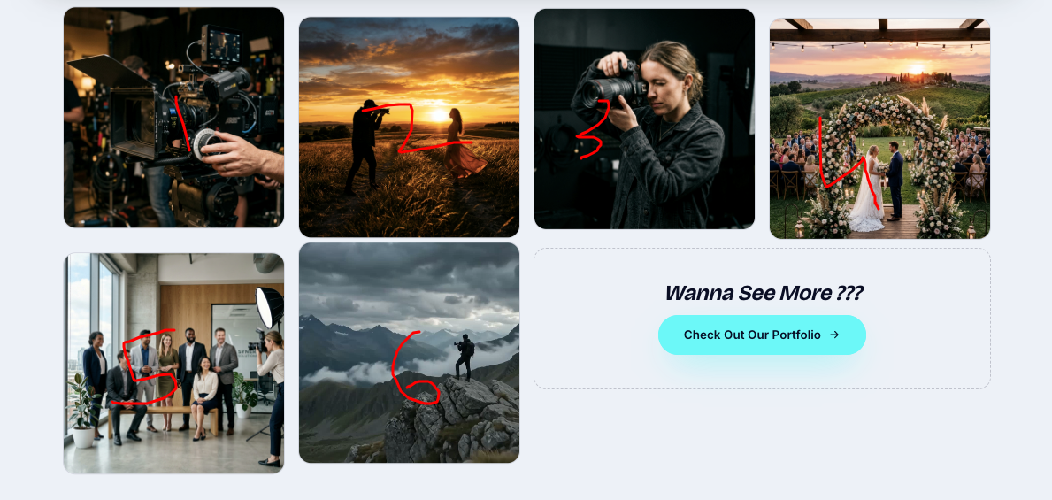

1- https://drive.google.com/file/d/1RYL2qXKl1lhVN_noEqkDbdrSJ5CxDs47/view?usp=drive_link
2- https://drive.google.com/file/d/1zqCSSDWXN14XtgZ6aOp0xZb2bUeG-5ob/view?usp=drive_link
3- https://drive.google.com/file/d/1bzb12etXrgCvgrf4tAlbWh2L4gRtcTvq/view?usp=drive_link
4- https://drive.google.com/file/d/1llaPAu_mhvSPLxzXOp_Jp4hh1Dk6cFqU/view?usp=drive_link
5- https://drive.google.com/file/d/1kMUPFpRA-PgByVJraVBjo00fHX_WRrME/view?usp=drive_link
6- https://drive.google.com/file/d/1ickjJS7dtnHb6egxOWntafbJoe1k_lcI/view?usp=drive_link

SERVICES PAGE

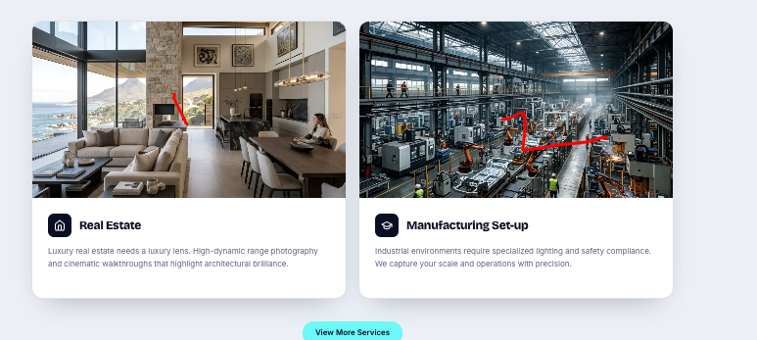
1- https://drive.google.com/file/d/1qH22nJT1GjhjHhpb7bj6xbYV8i6JsK2J/view?usp=drive_link
2- https://drive.google.com/file/d/1Lk366qkTzTmVAQn0g1EXMGvY7XEPCY65/view?usp=drive_link

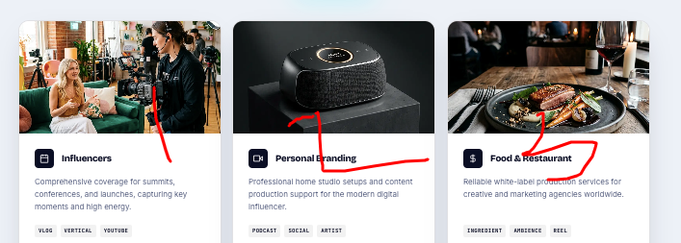

1- https://drive.google.com/file/d/1q2vYMoP3g9z6ibjQ8EwDMticRRJp8pEG/view?usp=drive_link
2- https://drive.google.com/file/d/1OkGnq3VeGB8o3CqQQrj_rqWbbojMW1Va/view?usp=drive_link
3- https://drive.google.com/file/d/18ceDh3QVqQ4nVhYHUEj-BLdhCL20QfTr/view?usp=drive_link

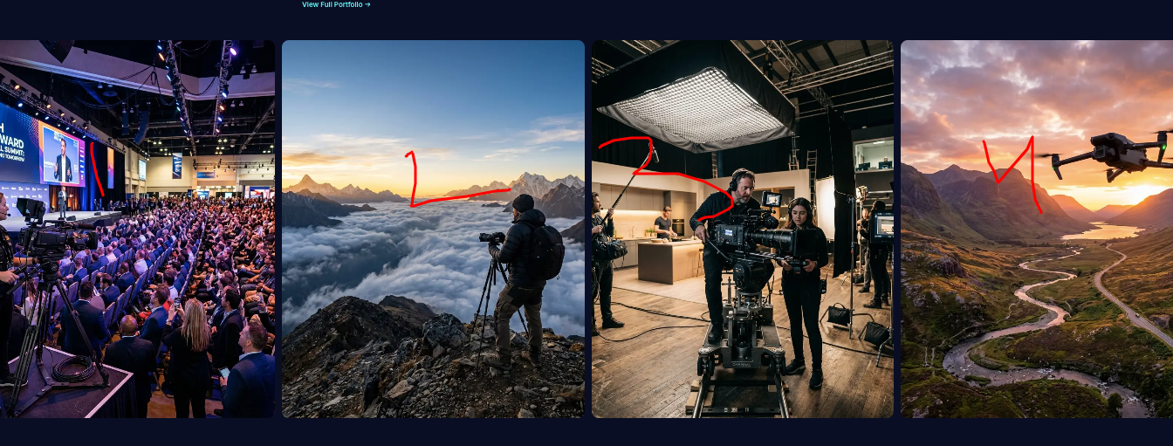

1- ttps://drive.google.com/file/d/1Nq2q-mfbREJQ4GNXx4k4A7bzfPD8698s/view?usp=drive_link
2-https://drive.google.com/file/d/1g4hbhMB_q9kQGTfUUA0O96AOVkIq9inq/view?usp=drive_link
3-https://drive.google.com/file/d/1XFjmkOaj3K01R7FWkZQEwabKKR84uzud/view?usp=drive_link
4- https://drive.google.com/file/d/1qZZxpsTw8awawUiHfOdXzaQ_PWMwB_fr/view?usp=drive_link

PORTFOLIO PAGE

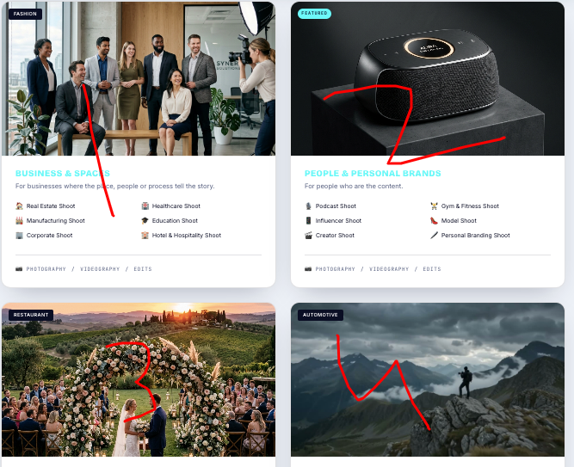
1- https://drive.google.com/file/d/1gRjrw_RScWVBZTtPLg8FF3WXA2I9rcw4/view?usp=drive_link
2- https://drive.google.com/file/d/1lXM0JQRlgb4yBndEmht2E09uvCAiwEtC/view?usp=drive_link
3- https://drive.google.com/file/d/1aqMxpQsIvScG5js5jdtvCQBkh5jIRokl/view?usp=drive_link
4- https://drive.google.com/file/d/1O8ocdsK11nLB-6AteU9zyWC0ZiCZfvVe/view?usp=drive_link

PRICING PAGE
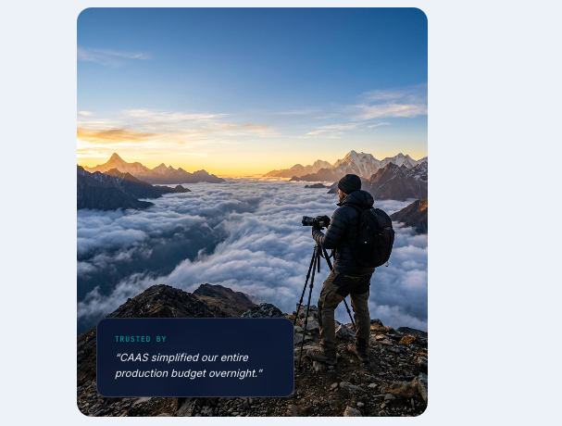
Link - https://drive.google.com/file/d/13R0LUlJ1RIhC8BHGzCsVNe6uO_ic1amr/view?usp=drive_link

